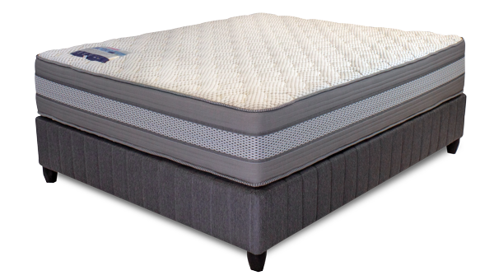


Model : Arctic Gentle Base Set
Supplier/Manufacturer : Rest Assured
Range : Evolution Pocket Spring Collection
Prices – Bed Set :
- Single Bed Set – R15329
- Three Quarter Bed Set – R19439
- Double Bed Set – R22369
- Queen Bed Set – R24109
- King Bed Set – R29349
Prices – Mattress Only :
- Single Mattress Only – R13669
- Three Quarter Mattress Only – R17599
- Double Mattress Only – R20339
- Queen Mattress Only – R22029
- King Mattress Only – R26029
Prices - Extra Length Bed Set :
- Single Extra Length Bed Set – R16559
- Three Quarter Extra Length Bed Set – R20999
- Double Extra Length Bed Set – R24159
- Queen Extra Length Bed Set – R26039
- King Extra Length Bed Set – R31699
Prices - Extra Length Mattress Only :
- Single Extra Length Mattress Only – R14769
- Three Quarter Extra Length Mattress Only – R19009
- Double Extra Length Mattress Only – R21969
- Queen Extra Length Mattress Only – R23799
- King Extra Length Mattress Only – R28119

*Please use this link for guideline for creating the page* - https://www.bedsonline.co.za/product/rest-assured-arctic-gentle-queen/
Rest Assured Link - https://restassured.co.za/our-ranges/evolution/arctic/

